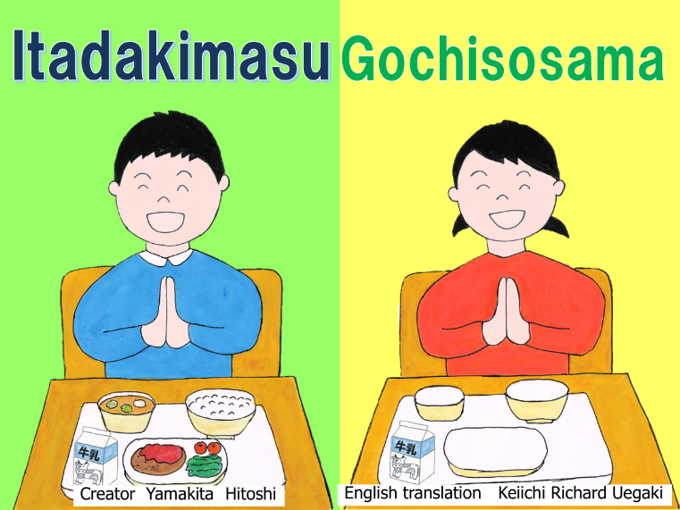

➀When we eat a meal, why do we say "Itadakimasu" before the meal and “Gochisōsama” after the meal?

Let's think about the meaning of the words "Itadakimasu" and " Gochisōsama ".

Note: It is the Japanese culture to say “Itadakimasu” before the meal and “Gochisosama” after the meal.

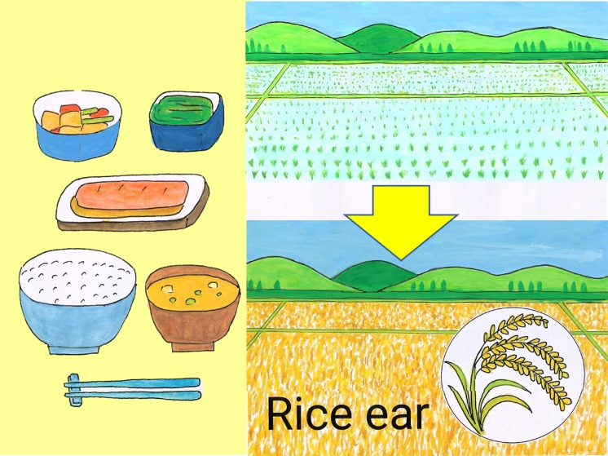

② The answer is in the daily meals we are eating. Rice grew up in the rice field.

The grain in the ear of rice becomes rice.

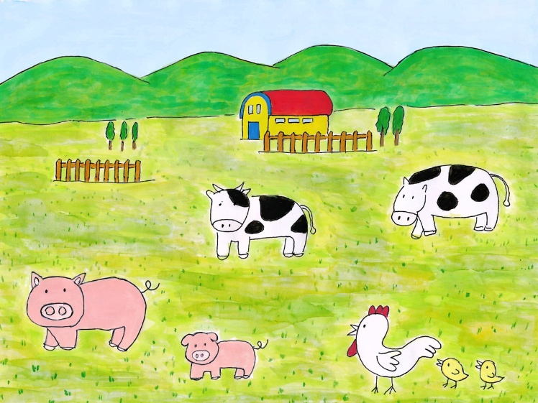

③ The cows were raised on the ranch. The pigs and chickens grew up in places where they were raised.

④ Fishes such as tuna, bonito, salmon, saury, mackerel, sardines, and sea breams were swimming in the sea.

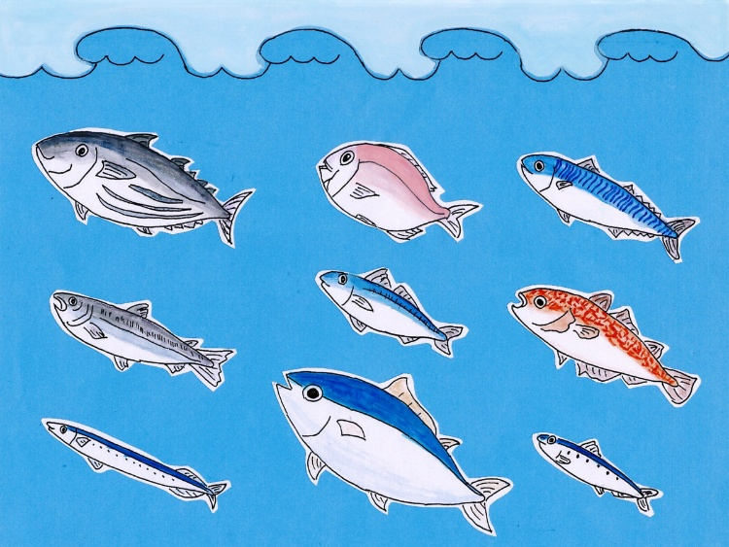

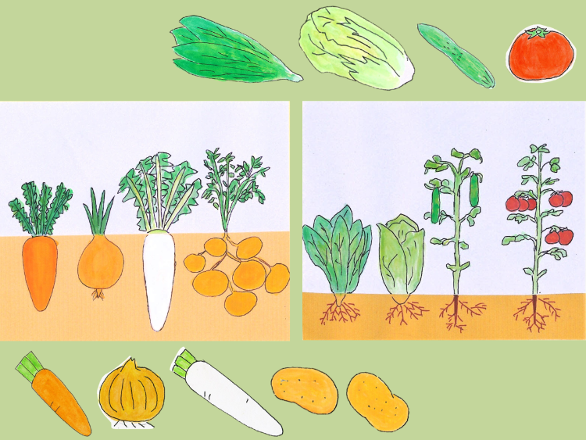

⑤ Spinach, Chinese cabbage, cucumber, and tomato were grown on the soil of the field, and carrots, onions, radishes, and potatoes were grown in the soil.

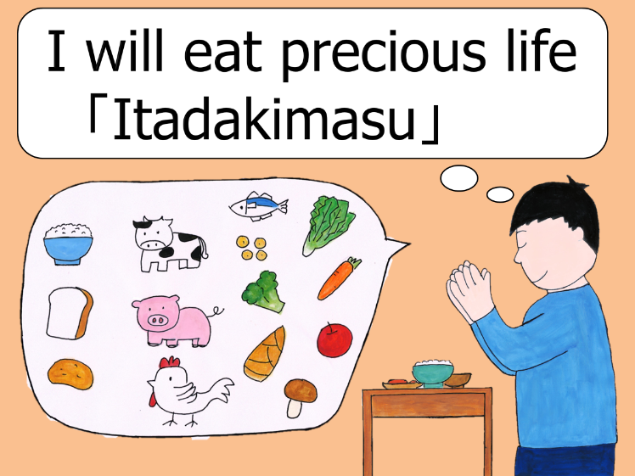

⑥ We can live by eating food. If we don't eat food, we can't live. The rice, meat, fish, and vegetables we eat every day were all alive at one point. We thank and respect all the lives that became food for us by saying “Itadakimasu” which means “I am going to eat the precious life.”

⑦ Then why do we say " gochisōsama " after a meal?

In the olden days, when preparing meals to the customers, there was no refrigerator where people could store food like you do now, and there was no grocery in the neighborhood where people could go buy groceries.

It was difficult to prepare the ingredients for cooking. People went out to the sea to catch fish, went to the mountains and picked mushrooms, and ran around to collect ingredients.

Running around like this is called "chisō".

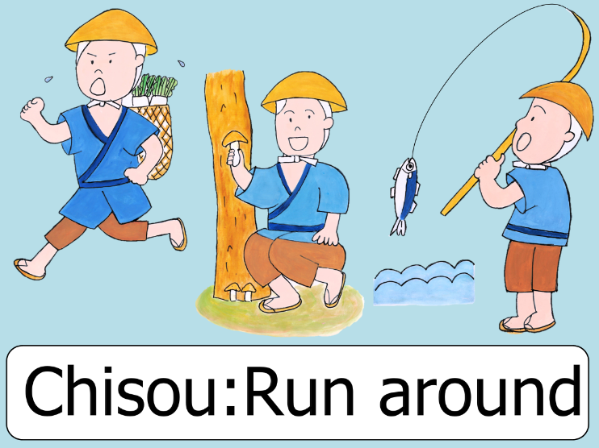

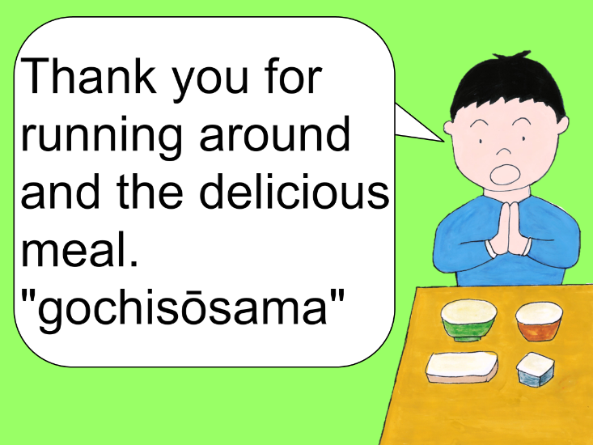

⑧ The customer who ate the food prepared in this way said, "Thank you for running around (chisō ) to prepare this delicious meal." It became a tradition for the customers to say "Gochisōsama" to show the appreciation to people who prepared the food.

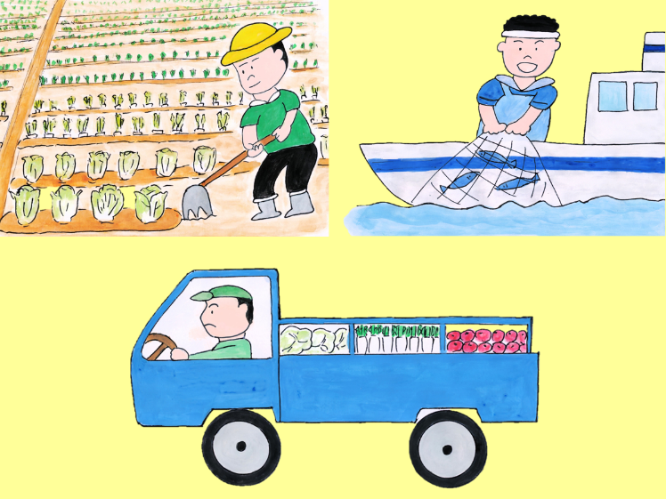

⑨Now you can collect the ingredients without having to run around like we used to, but there are farmers who grow rice and vegetables, fishermen who catch fishes, and drivers who will transport the ingredients to the school lunchroom.

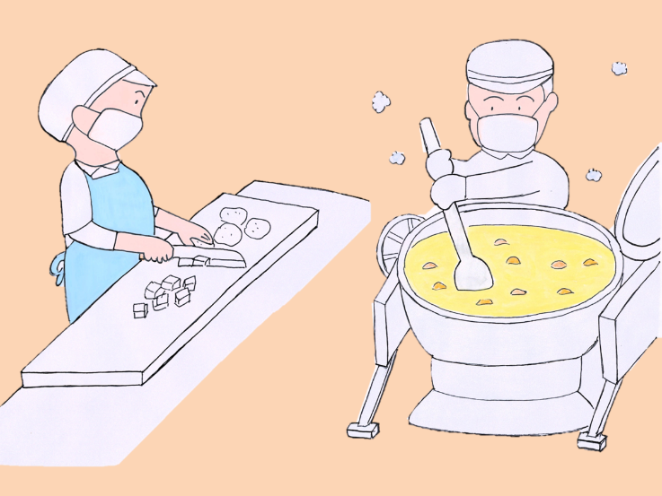

⑩ Those ingredients are handled and cooked by many hard-working people to cook and prepare a delicious school lunch.

Let's say "Gochisōsama" to express our gratitude to the people who produced the ingredients, the people who delivered it, the people who cooked the food, and everyone else.

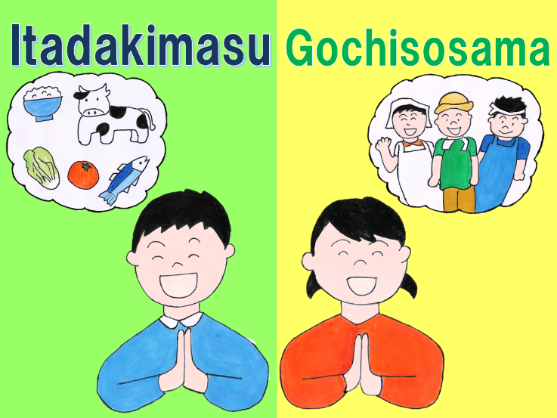

⑪ “Itadakimasu” is a word used to express our “gratitude” to the lives that have been eaten for us.

"Gochisōsama" is a word used to express our "appreciation" to the people who have worked hard to prepare the meal that was just eaten.

When you eat, put your hands together and say "Itadakimasu" and "Gochisōsama " in a cheerful voice.