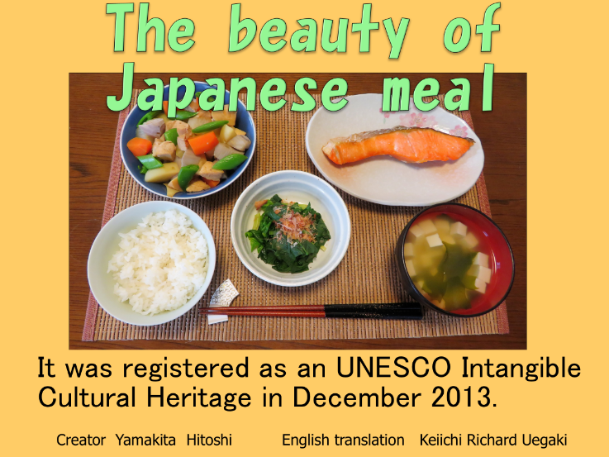

①The form of meal that has been eaten in Japan for a long time is called Japanese-style meal.

Japanese-style meal is a traditional Japanese meal with a focus on rice.

It was registered as an UNESCO Intangible Cultural Heritage in December 2013.

Japanese-style meal has many good factors.

Let’s look into the key factors of Japanese-style meal.

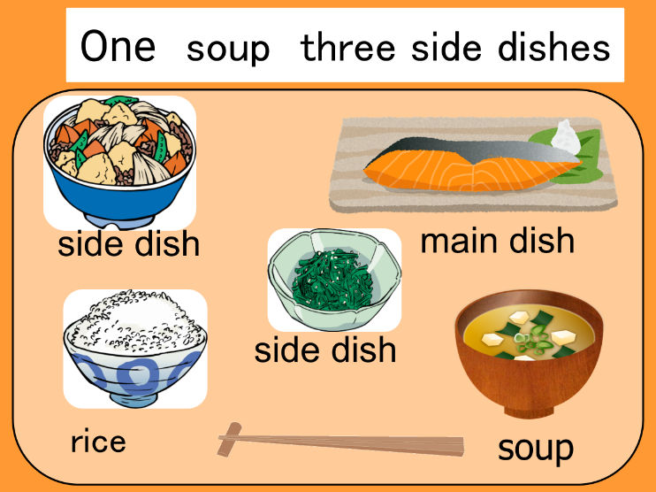

②The fundament of Japanese-style meal is the "one soup, three side dishes,”

which is a combination of rice, soup, and side dishes made from ingredients such as seafood,

beans, and vegetables.

Japanese-style meal is a form of a meal focused on rice.

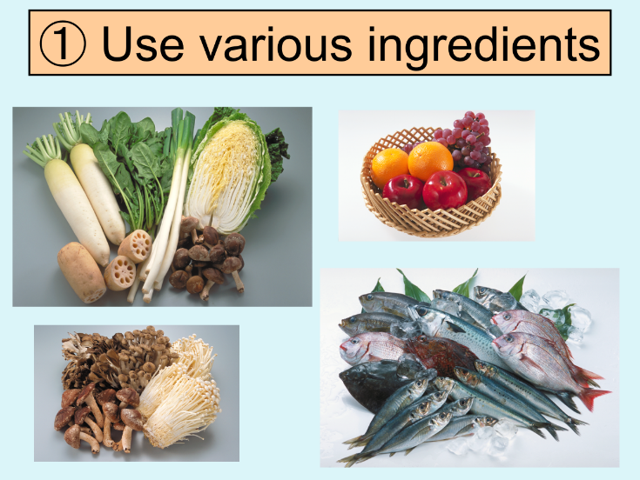

③ "Introducing the key factors of Japanese-style meal "

➀Japanese-style meal uses various ingredients.

Tip to tip, the land of Japan is long, and the seasons of spring, summer, autumn, and winter are clearly vivid.

For Japanese food, it is important to use seasonal foods, such as fresh vegetables and fishes, which are harvested in various places in each season.

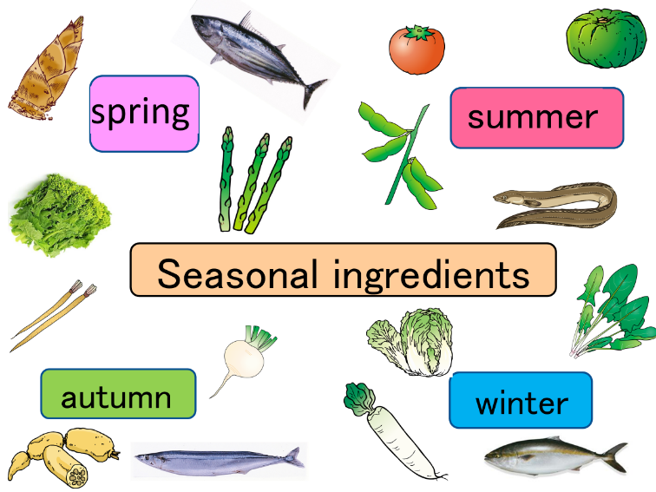

④ For example, bamboo shoots, bonito, field mustard, and asparagus are in season in spring.

Tomato, pumpkin, edamame, and hamo are in season in summer.

Burdock, turnip, lotus root, and mackerel pike are in season in autumn.

Chinese cabbage, spinach, radish, and yellowtail are in season in winter.

There are various seasonal ingredients for each season.

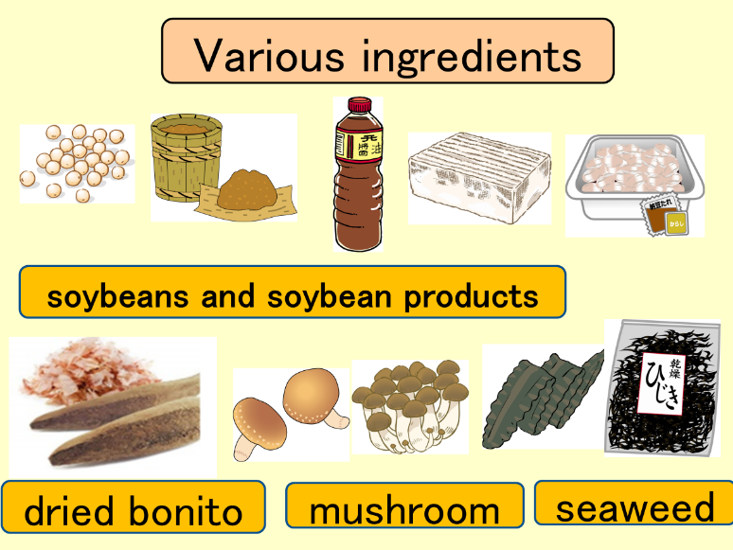

⑤ Processed soybean foods such as miso, soy sauce, bean curd, and natto,

and various ingredients such as fermented foods, dried bonito, mushrooms, and seaweed are used.

⑥　② Good nutritional balance.

By using rice as a staple food, you can eat various foods together. Traditional Japanese meal form,

"one soup, three side dishes," provides a good balance of nutrients necessary for maintaining good health.

The staple food is rice. It will be the food of the yellow group, which is the main source of energy.

The main dish uses ingredients such as meat, fish, and egg.

It is a food of the red group that mainly makes the body.

Side dishes use ingredients such as vegetables, potatoes, mushrooms, beans.

Most of the foods in the green group are used to keep one in good physical condition.

Besides the side dishes, there are small side dishes.

These include boiled or vinegared dish made of ingredients such as vegetables and seaweed.

It contains a lot of green group foods that keep you in shape.

The soup contains various foods such as vegetables, potatoes, soybeans, tofu, and seaweed.

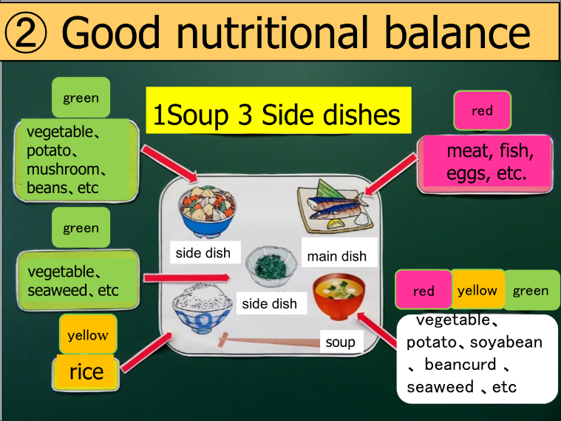

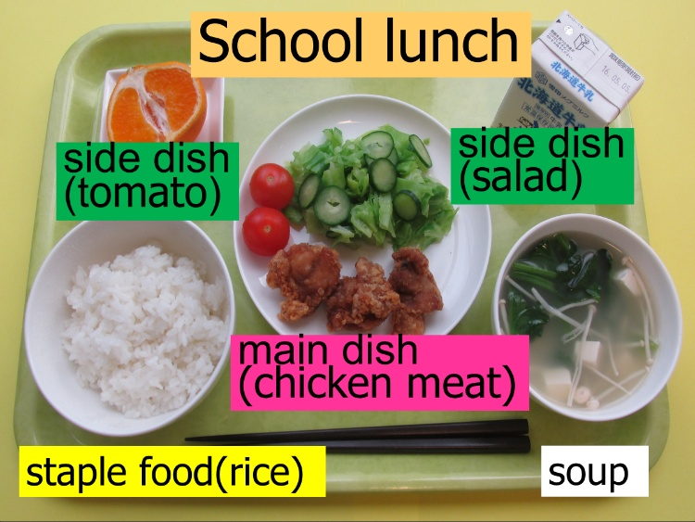

⑦ The menu for school lunch meals are also nutritionally well-balanced.

It comes with a staple food, main dish, two side dishes, and a soup.

⑧ ③Japanese-style meal is a meal that makes you enjoy the feeling of the season.

In Japan, you can get various ingredients every four seasons.

You can enjoy the seasonality by cooking seasonal foods.

For example, you can enjoy cooking by using bamboo shoots in spring to cook "bamboo shoot rice,"

summer vegetables to cook "cold somen" "grilled saury" in autumn,

and "pot dishes" using seasonal seafood and winter vegetables in winter.

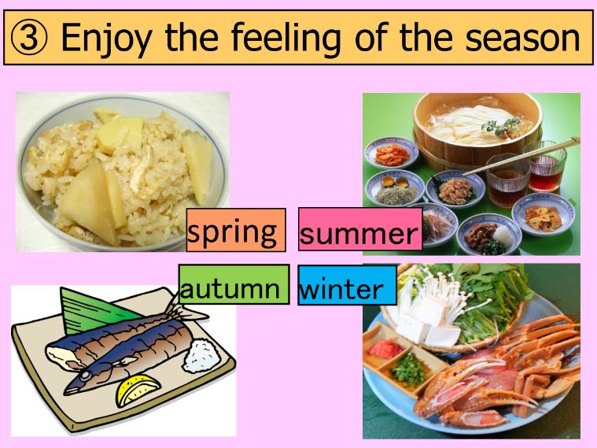

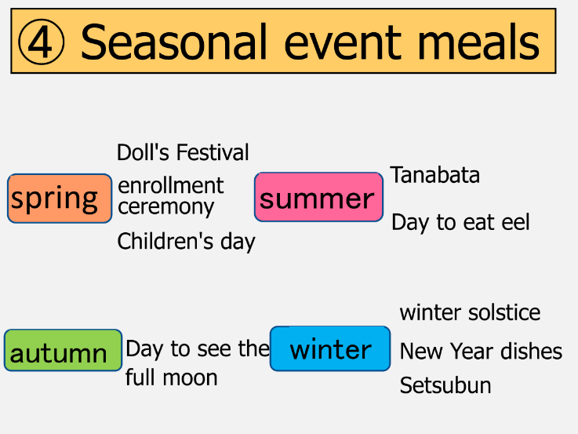

⑨ ④ You can enjoy eating with your family and people around you with seasonal events and event meals that you eat on celebration days.

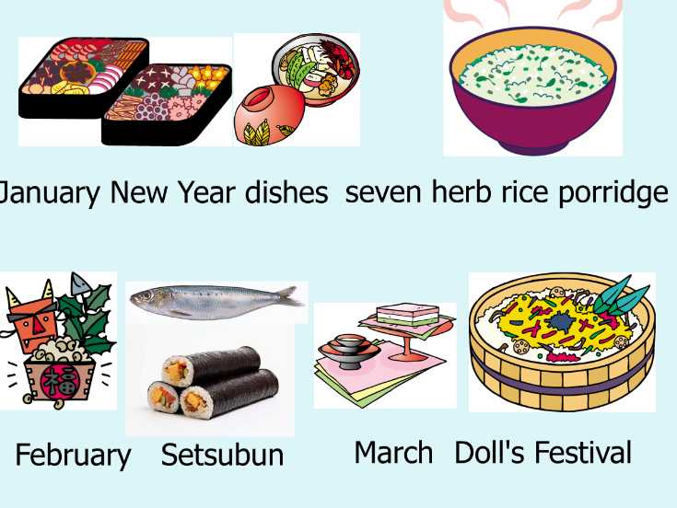

⑩ January's event meals are New Year dishes and seven herb rice porridge.

February's event meals are Setsubun sardine and makizushi (rolled sushi).

March's event meal is Doll's Festival chirashizushi.

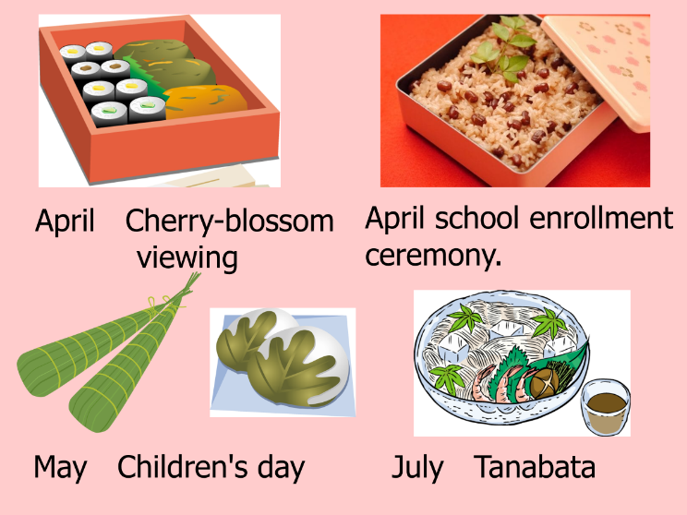

⑪April's event meals are cherry-blossom viewing lunch and red rice for the school enrollment ceremony.

May's event meals are Children's Day chimaki and Kashiwa mochi. July's event meal is somen for Tanabata.

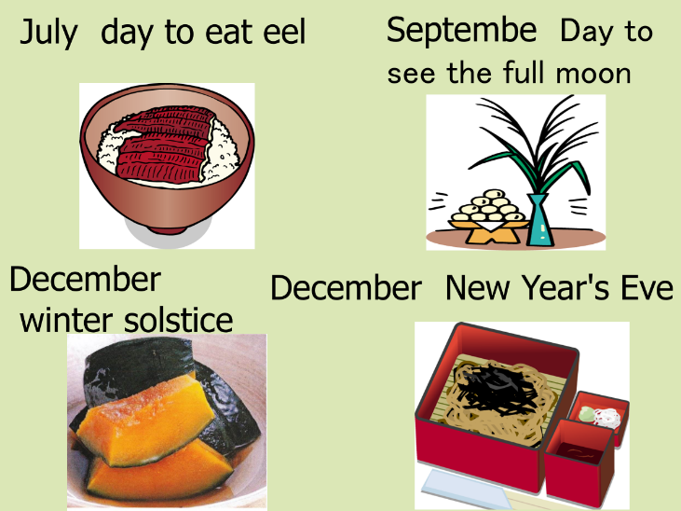

⑫July's event meal is eel. September's event meal is Japanese dumpling while viewing the full moon.

December's event meal is kabocha pumpkin on the day of the winter solstice.

Toshikoshi Soba, a traditional Japanese noodle, is eaten on New Year's Eve.

There are various event meals throughout the year.

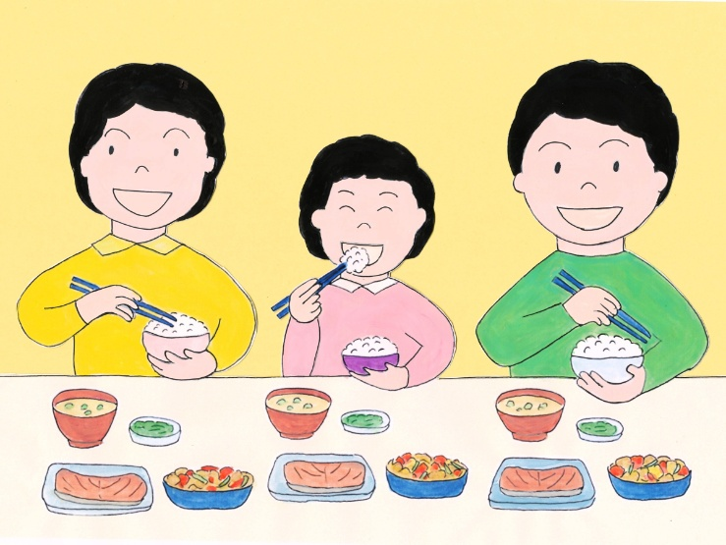

⑬ Japanese-style meal makes you enjoy the tastes of various ingredients,

has a nutritionally balanced meal, and gives you a sense of the seasons.

The event foods that you eat at seasonal events can be enjoyed by your family and friends.

Let's be willing to eat while enjoying Japanese-style meal based on rice.