Year-end and New Year event food(picture- story show)

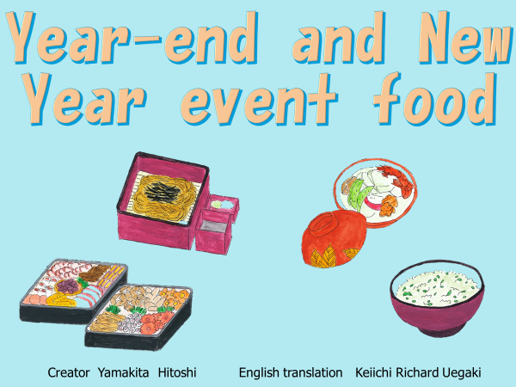

➀ At the end of the year in December and the beginning of the year in January, there are various events and meals to eat at the time of the event.

Each of the event meals eaten on event days has a special meaning. Let's think about the meaning of each event and the event food with a quiz.

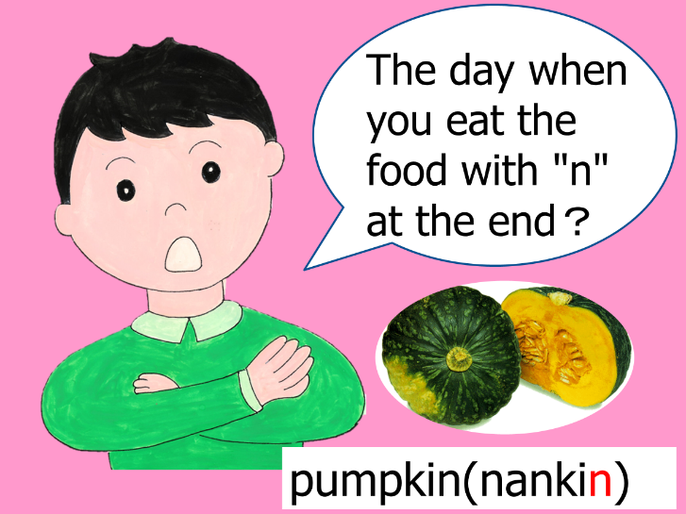

②We will give a quiz about Year-end and New Year event food.

Quiz: Pumpkin is called "nankin" in Japanese.

In addition to nankin, what is the event of eating foods with "n" at the end in Japanese such as "ninjin(carrot)" and "renkon(lotus root)"?

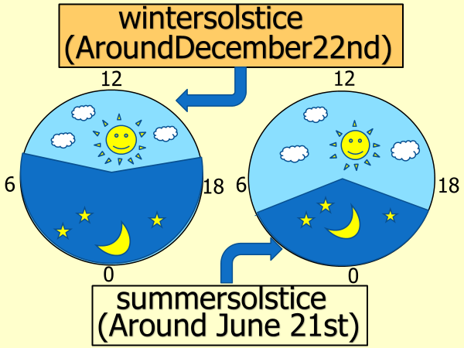

③ The answer is the winter solstice.

Winter solstice is the day when the sun illuminates the ground for the shortest time of the year.

It will occur around December 21st or 22nd of every year.

On the other hand, the day when the sun illuminates the ground for the longest time of the year is called the summer solstice which happens every year around June 21st or 22nd.

On the day of　the winter solstice, we eat pumpkin.

In Japan, eating pumpkin on this day is said to prevent catching a cold or illness.

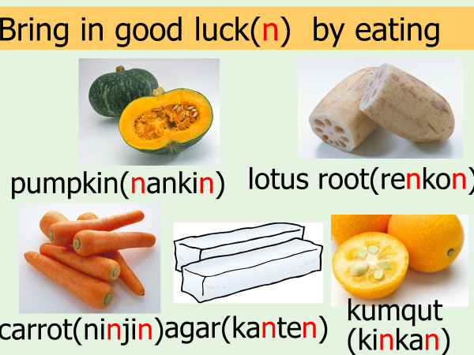

④It is said that if you eat food that ends in "n" in Japanese, it will bring you good luck.

In addition to "kabocha (pumpkin)", there is a tradition of eating "renkon (lotus root)", "ninjin (carrot)", "kanten (agar)", and "kinkan (kumquat)".

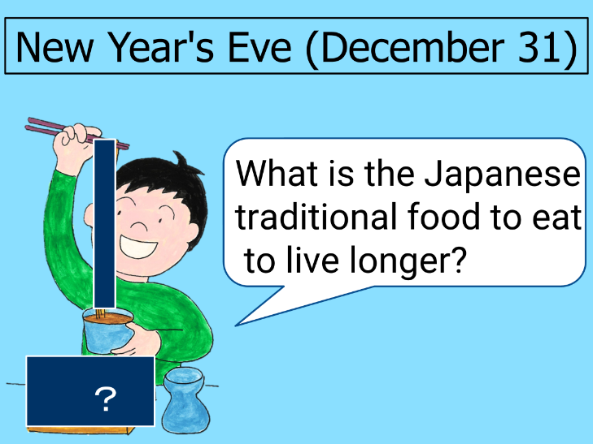

⑤ Quiz: What is the Japanese food to eat on Omisoka(New Year's Eve)?

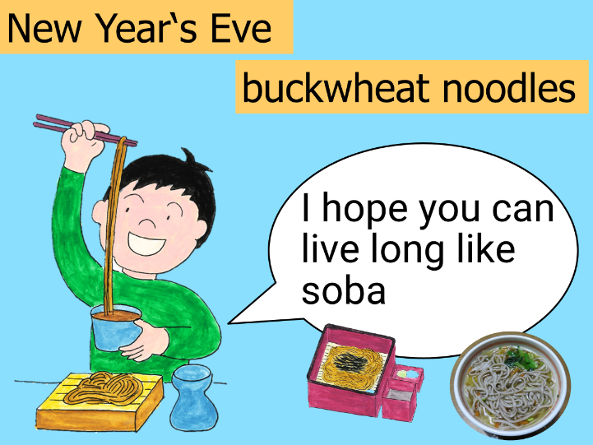

⑥ The answer is soba (buckwheat noodles).

Once upon a time, the last day of the month was called "misoka" in Japanese.

Since December 31st is the last "misoka" of the year, it is called "Omisoka("O" means "great" in Japanese)."

On New Year's Eve, it is the tradition to eat soba with the wish of good health and longevity and to live long like soba.

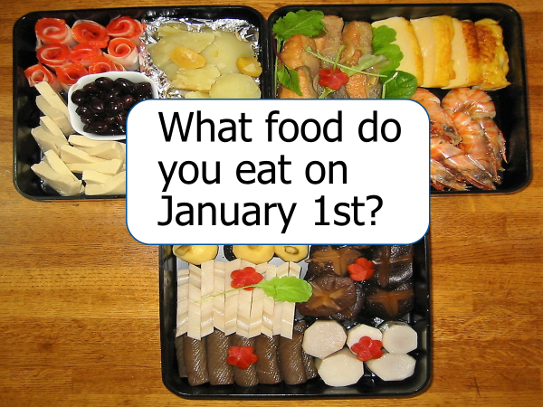

⑦ Quiz: What is the traditional Japanese food that is to be eaten on New Year's Day?

It is Osechi ryori.

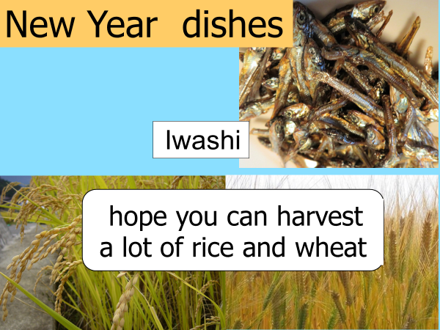

⑧ We eat "Osechi ryori" on New Year's Day to celebrate the new year.

Osechi ryori includes various dishes in the hope that the new year is going to be a good year.

Each dish in Osechi ryori has its unique meaning.

"Iwashi" was used as a fertilizer for rice and wheat fields in the old days.

Hoping to reap sufficient rice and wheat this year as well, osechi ryori includes dried iwashi that is cooked sweet and spicy.

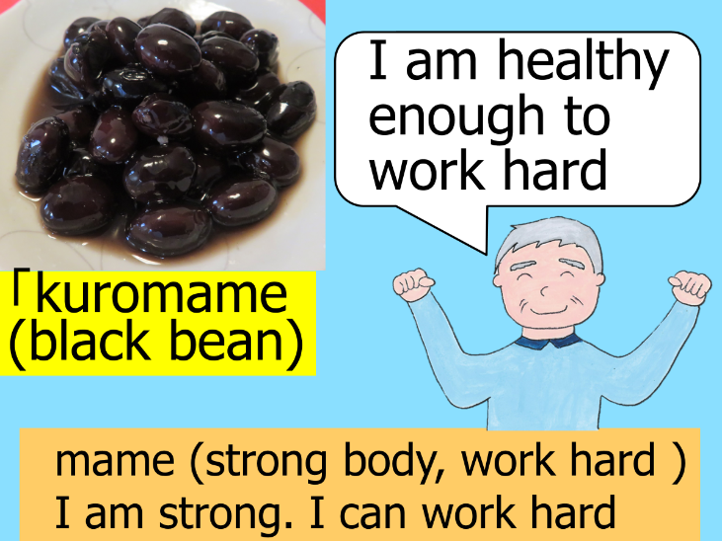

⑨ Osechi ryori includes kuromame (black beans). Kuromame includes the word "mame" which is beans but also a homophone for "strong body" and "work hard."

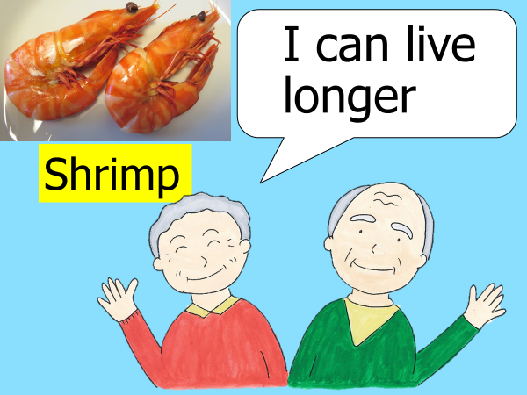

⑩ The long-bearded, bent-back shrimp looks like an elderly person. It is the tradition to eat shrimp in osechi ryori to live long like an elderly person.

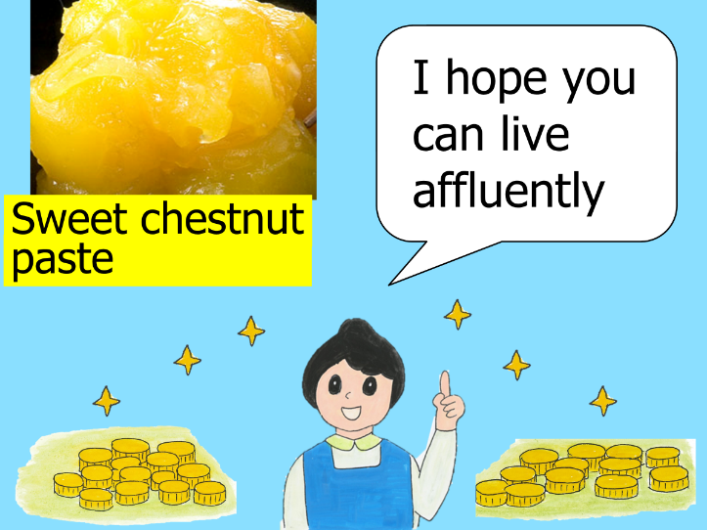

⑪ Kuri kinton (Sweetened chestnuts) looks like a treasure that shines in golden color.

Osechi ryori includes kuri kinton in the hope that the person who eats will live wealthy.

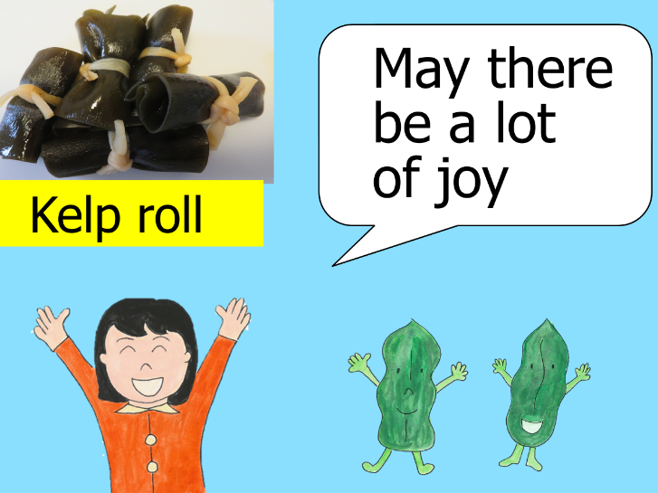

⑫ Konbu Maki kelp is eaten in the hope that there will be a lot of joy by connecting it to the Japanese word "yorokobu (joy)".

⑬ Herring roe "kazunoko" has a large number of eggs, so it is included in the osechi ryori to pray for healthy children and the prosperity of descendants.

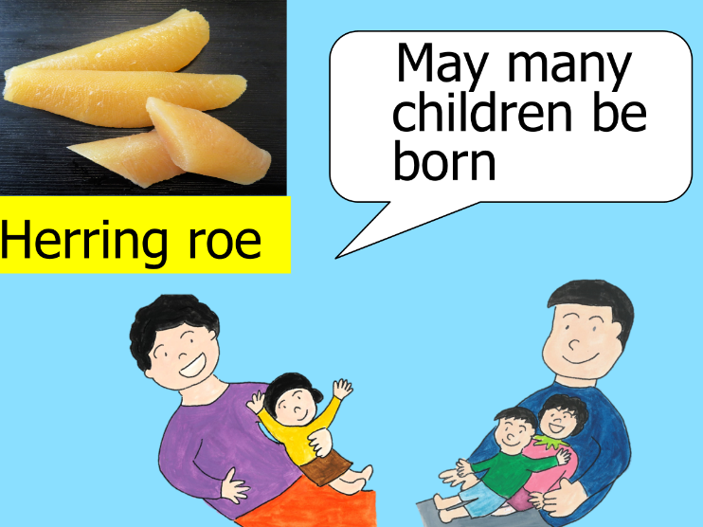

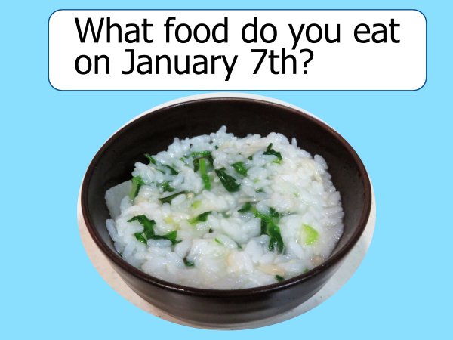

⑭ Quiz: What is the name of the traditional Japanese food that is to be eaten on January 7th?

It is nanakusa gayu.

⑮ On January 7th, it is the Japanese tradition to eat nanakusa gayu containing the spring seven herbs "Seri (water dropwort), Nazuna (shepherd's purse), Gogyo (cudweed), Hakobera (chickweed), Hotoke no Za (nipplewort), Suzuna (turnip), Suzushiro (Daikon radish)".

Porridge is used to soothe a tired stomach after overeating on New Year's Day, and it also has the meaning of supplying vegetables with nutrients during the winter when vegetables tend to be in short supply. By eating nanakusa gayu on January 7th, people wish for good health for the year ahead.

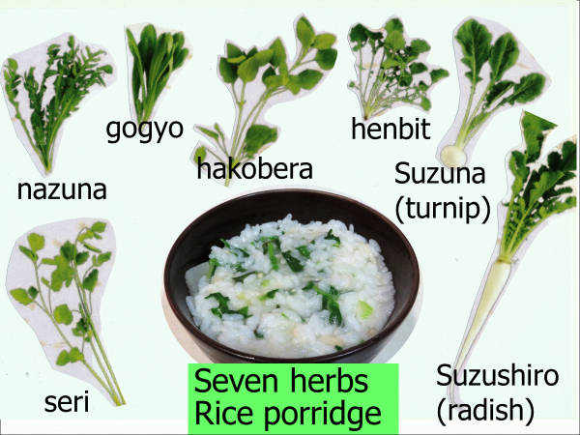

⑯ Each event food that appears at the end of the year and the beginning of the year has a meaning.

In Japan, on days when we eat event food, we think about its meaning when eating.

